SIMATS ENGINEERING (SAVEETHA SCHOOL OF ENGINEERING)
Department of Computer Science and Engineering

ASSESSMENT TOOL 1 – APPLICATION BASED QUESTIONS

Course Code: | CSA06 | Course Title: | Design and Analysis of Algorithms
CO Assessed: | CO1 – Precision (BL1, BL2, BL3) | Assessment: | Assessment Tool 1 – Application Based Questions
Weightage: | 40% of CIA | Total Marks: | 100 (2 Questions × 50 Marks)
CO1 Statement: | Determine algorithm efficiency using asymptotic notations and mathematical techniques including Master Theorem and substitution method. (BL1, BL2, BL3)
Student Name: | Ishwariya P | Reg. No.: | 192524445
Section / Batch: | 2025 | Date: | 16.07.2026

Instructions to Students
- Answer BOTH questions. Each question carries 50 Marks. Total: 100 Marks.
- Clearly show all steps in derivations and complexity analysis.
- Use proper asymptotic notation (Big-O, Big-Θ, Big-Ω) wherever required.
- Justify each step in recurrence solving using appropriate methods.
- Neat presentation and logical explanation are mandatory

Question Type | Focus Area | Questions | Marks
Application-Based Questions | Apply Master Theorem and asymptotic analysis to real-world scenarios | Q1 – Q2 | Q1 –50  Q2 –50
GRAND TOTAL: |  | 100 Marks

SECTION A – APPLICATION BASED QUESTIONS

Q1. Cloud Backup Analysis System A cloud system processes backup data using the recurrence T(n) = T(n/2) + n. Recall recurrence solving techniques, explain how the function grows, and determine the asymptotic time complexity using an appropriate method. Also analyze the space complexity of the recursive calls

Q2. Software Log Sorting System One log sorting algorithm takes O(n log n) time, while another takes O(n²) time. Compare both algorithms using asymptotic notation, explain differences in growth rates, and decide which is better for large datasets. Also compare their space complexities and identify the more memory-efficient choice

Code of Conduct
I Ishwariya P(192524445) (Name / Reg No) certify that this submission is my original work and that I have adhered to the guidelines specified for this assessment. I understand that any violation of academic integrity rules will result in disciplinary action.
Signature of the Student: Ishwariya P_________________________
RUBRICS FOR CALCULATION
Criteria | Wt. | Level 4 – Exemplary | Level 3 – Proficient | Level 2 – Developing | Level 1 – Beginning
Understanding of Problem Context | 20% | Clearly understands the problem and accurately identifies all requirements | Good understanding with minor gaps | Basic understanding; some requirements unclear | Poor understanding or misinterpretation of the problem
Application of Concepts | 30% | Accurately applies appropriate concepts to solve complex problems | Applies relevant concepts correctly with minor errors | Applies basic concepts with limited accuracy | Fails to apply appropriate concepts
Problem-Solving Approach | 20% | Logical, well-structured, and efficient approach | Mostly logical approach with minor gaps | Basic approach with some inconsistencies | Illogical or unclear approach
Accuracy of Solution | 20% | Completely correct solution with proper justification | Mostly correct with minor errors | Partially correct solution | Incorrect or incomplete solution
Clarity | 10% | Clear, well-organized, and properly explained solution | Understandable with minor clarity issues | Limited clarity and explanation | Poorly presented and difficult to understand
Marks Evaluation:
Question No. | Understanding of Problem Context (20%) | Application of Concepts (30%) | Problem-Solving Approach (20%) | Accuracy of Solution (20%) | Clarity (10%) | Total Marks
Q1
(50 Marks)
Q2
(50 Marks)
Overall Total (100)

Faculty In-charge | Course Coordinator | Head of Department
Signature: _______________ | Signature: _______________ | Signature: _______________
Date: ___________________ | Date: ___________________ | Date: ___________________

Design and Analysis of Algorithms (CSA06) — Assessment Tool 1
Application-Based Questions — Full Solutions
Q1. Cloud Backup Analysis System
1. Problem Understanding
A cloud backup service must process a large volume of stored data every time it performs an incremental backup. The system repeatedly splits the total dataset of size n into two equal halves — for example, dividing data across mirrored storage shards or halving a search range while indexing changed blocks. However, unlike a typical divide-and-conquer algorithm, only ONE half is actually processed further (the other half is assumed already backed up / unchanged), while an additional linear-time operation of cost n is performed at every stage — such as scanning, checksum verification, or writing a change-log for all n data blocks before recursing. This behaviour is captured precisely by the recurrence:
T(n) = T(n/2) + n
Our goal is to determine exactly how the total processing time T(n) grows as the backup size n increases, so that the cloud provider can predict runtime for large datasets and provision resources accordingly.
2. Recurrence Relation — Identifying Parameters
The recurrence T(n) = T(n/2) + n is a standard linear (single-branch) divide-and-conquer recurrence. Comparing it with the general Master Theorem form:
T(n) = a·T(n/b) + f(n)
- a = 1 (one recursive sub-call is made per invocation)
- b = 2 (the problem size is halved at every recursive step)
- f(n) = n (the additional non-recursive work done at each level — e.g. scanning/verification of all n blocks)
3. Solving Using the Master Theorem (Step-by-Step)
Step 1 — Compute the watershed function n^(log_b a):
log_b(a) = log_2(1) = 0 ⟹ n^(log_b a) = n^0 = 1
Step 2 — Compare f(n) with n^(log_b a):
Here f(n) = n, while n^(log_b a) = 1. Since n grows strictly faster than the constant function 1, f(n) is polynomially LARGER than n^(log_b a). Formally, we must find an ε > 0 such that:
f(n) = Ω(n^(log_b a + ε))
Choosing ε = 1: f(n) = n = Ω(n^(0+1)) = Ω(n). This condition holds, so we test Case 3 of the Master Theorem.
Step 3 — Verify the regularity condition (required for Case 3):
a·f(n/b) ≤ c·f(n) for some constant c < 1, for all sufficiently large n
Substituting a = 1, b = 2, f(n) = n:
1 · (n/2) ≤ c·n ⟹ c = 1/2 < 1
The regularity condition is satisfied with c = 1/2. Therefore, all three conditions of Case 3 of the Master Theorem hold.
Step 4 — Apply Case 3 of the Master Theorem:
If f(n) = Ω(n^(log_b a + ε)) for some ε > 0, and a·f(n/b) ≤ c·f(n), then T(n) = Θ(f(n))
⟹ T(n) = Θ(n)
4. Verification by Recursion-Tree / Iteration Method
We can double-check this result by unrolling the recurrence directly:
T(n) = n + n/2 + n/4 + n/8 + ... + 1
This is a geometric series with first term n and common ratio 1/2, having log2(n) terms until the base case T(1) is reached. Summing the series:
T(n) = n · (1 + 1/2 + 1/4 + ... ) ≈ n · 2 = 2n
Since constants are dropped in asymptotic analysis, this confirms:
T(n) = Θ(n)
5. Recursive Call Tree Diagram
The diagram below shows how the problem size shrinks by half at each recursive call, and the linear amount of extra work (the '+n' term) performed at each level before recursing further:
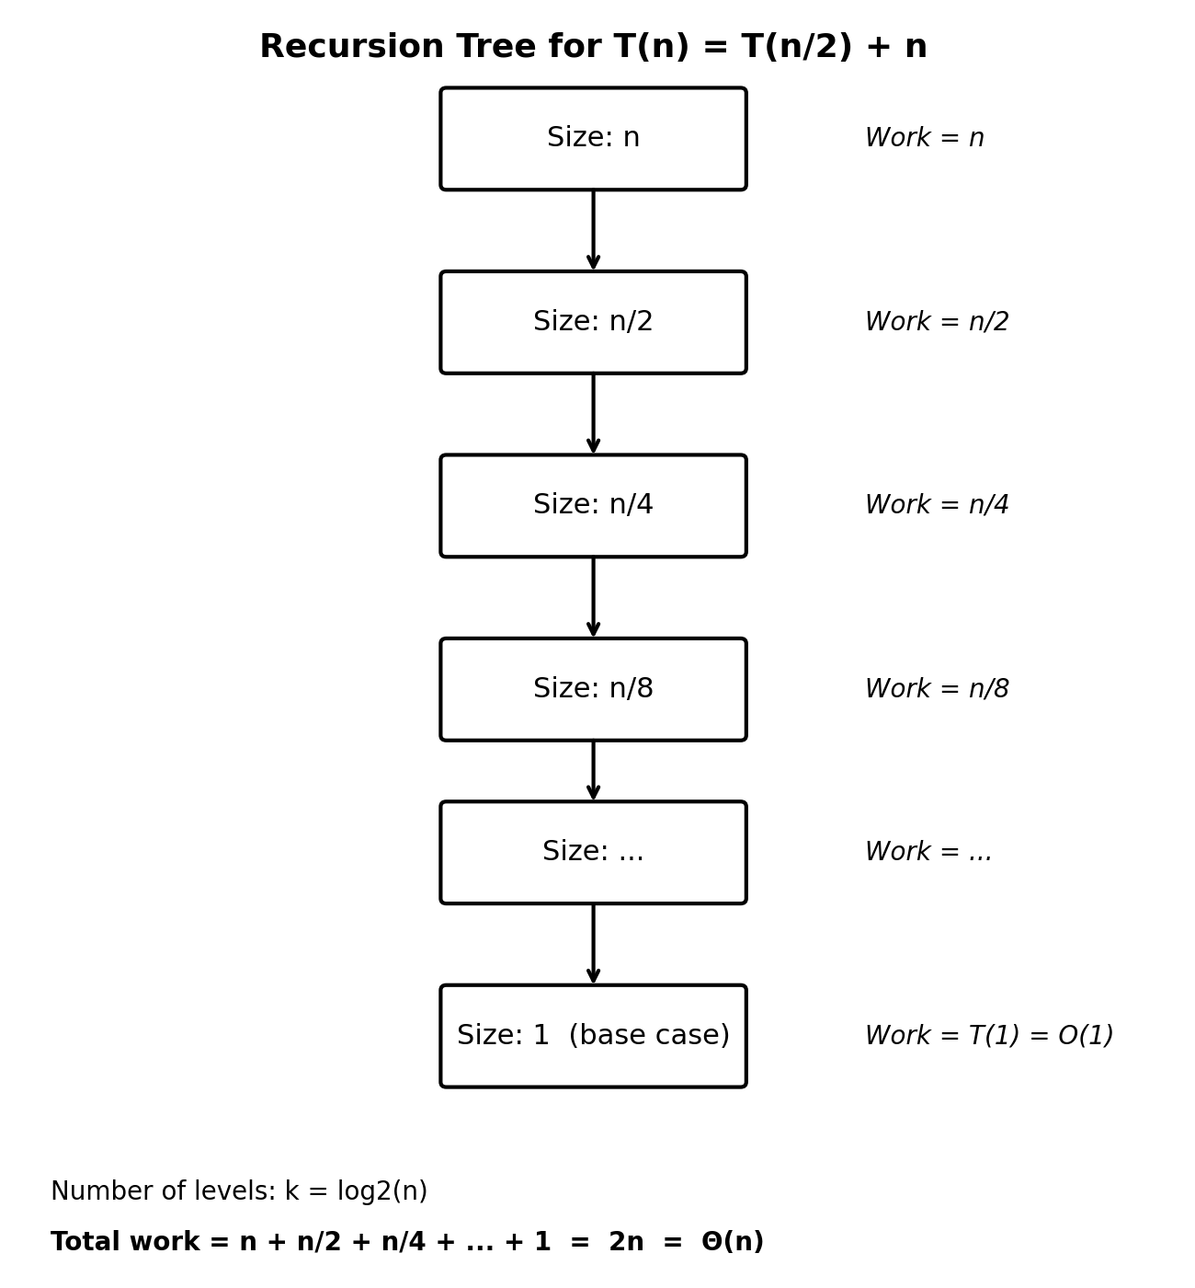
Fig 1: Recursive call chain for T(n) = T(n/2) + n — a single branching path (a = 1), not a branching tree.
Note: because a = 1 (only one recursive call is made), this is technically a recursion CHAIN rather than a branching tree — each level has exactly one child. The total work is dominated by the cost at the very first (top) level, since each subsequent level contributes a geometrically decreasing amount of work (n/2, n/4, n/8, ...), and the sum of this decreasing series converges to Θ(n).
6. Growth of the Function
Because T(n) = Θ(n), the backup-processing time grows LINEARLY with the size of the dataset. If the amount of data to back up doubles, the processing time also approximately doubles — there is no multiplicative blow-up from the recursive splitting, because splitting itself is 'free' compared to the linear scanning cost that dominates every level.
7. Asymptotic Time Complexity
Upper Bound (Big-O): T(n) = O(n)
Lower Bound (Big-Ω): T(n) = Ω(n)
Tight Bound (Big-Θ): T(n) = Θ(n)
Since the upper and lower bounds coincide, Θ(n) is the exact, tight asymptotic complexity of the cloud backup algorithm.
8. Space Complexity of Recursive Calls
Each recursive call to Solve(n/2^i) must remain on the call stack until its child call returns (since it still has pending work, or simply awaits the return value). The recursion terminates when the problem size reduces to 1, which takes log2(n) levels of recursion.
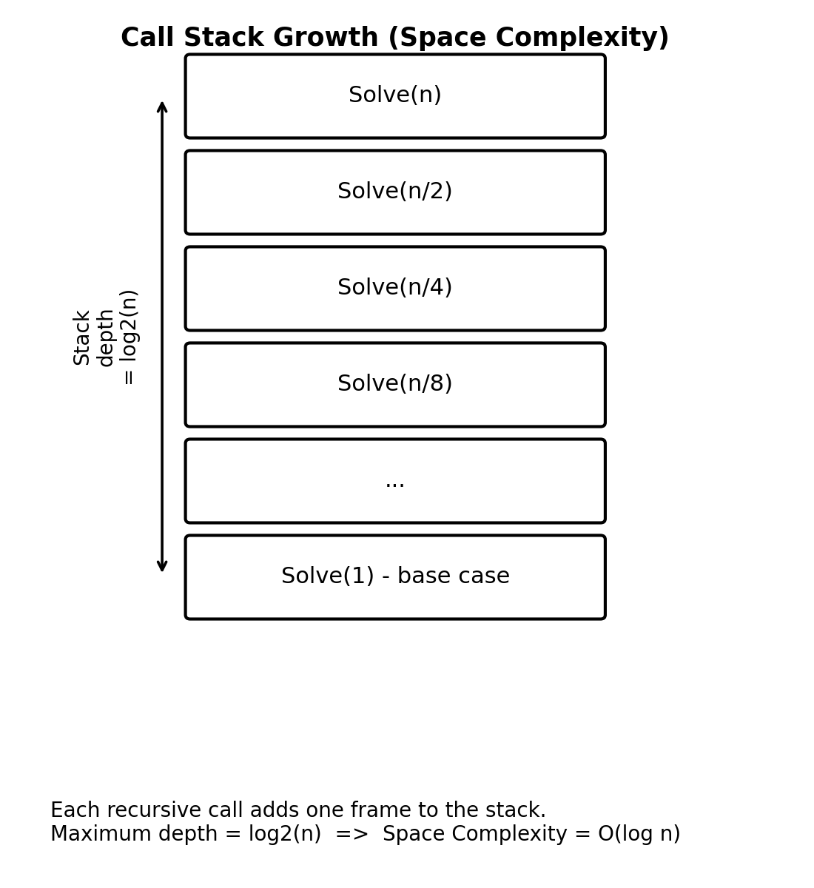
Fig 2: Call-stack depth grows proportionally to log2(n).
Space Complexity = O(log n)
This is because at any point in time, only ONE path of the recursion chain is active on the stack (there is no second recursive branch running in parallel), and the maximum depth of that single path is log2(n).
9. Final Conclusion
The recurrence T(n) = T(n/2) + n models a cloud backup system that halves its working data set at each stage while performing linear-time scanning/verification work at every level. Applying Case 3 of the Master Theorem (after verifying both the polynomial-difference condition and the regularity condition) proves that:
T(n) = Θ(n), with auxiliary space O(log n)
This tells the cloud provider that backup time scales linearly with data volume, and that memory overhead from recursion is only logarithmic — making the algorithm highly scalable and memory-efficient even for very large datasets.

Q2. Software Log Sorting System
1. Problem Understanding
A software monitoring platform collects massive volumes of log entries (timestamps, error codes, service names) that must be sorted — for example, to display the most recent errors first, or to merge logs from multiple servers in chronological order. The engineering team is choosing between two candidate sorting algorithms for this log-sorting service:
- Algorithm A — runs in O(n log n) time (e.g., Merge Sort / Heap Sort).
- Algorithm B — runs in O(n²) time (e.g., Bubble Sort / Insertion Sort).
Since production log volumes (n) can range from a few thousand entries to several hundred million entries per day, the choice of algorithm has a direct and significant impact on system responsiveness, server cost, and scalability. We analyze both algorithms formally using asymptotic notation to justify the correct engineering decision.
2. Big-O, Big-Θ, Big-Ω Comparison
Each algorithm's running time is expressed using the three standard asymptotic notations:
- Big-O (Upper Bound): worst-case guarantee — the algorithm will NEVER take longer than this.
- Big-Ω (Lower Bound): best-case guarantee — the algorithm can NEVER be faster than this.
- Big-Θ (Tight Bound): used when the upper and lower bounds match, giving the exact growth rate.
Algorithm A: O(n log n), Ω(n log n), Θ(n log n)
Algorithm B: O(n²), Ω(n), Θ(n²) [Θ(n) only for already-sorted input in Insertion Sort]
Note: Algorithm A (e.g., Merge Sort) has the SAME complexity in the best, average, and worst case — Θ(n log n) — making its performance highly predictable. Algorithm B's performance can vary: an already-sorted log stream may sort in O(n) time with Insertion Sort, but a randomly-ordered or reverse-ordered stream (the common real-world case for merged multi-server logs) triggers the O(n²) worst case.
3. Growth-Rate Explanation
The dominant term n log n grows only slightly faster than n itself (the log2(n) factor increases very slowly — for n = 1,000,000, log2(n) ≈ 20). In stark contrast, n² grows quadratically — multiplying the input size by 10 increases Algorithm B's work by 100×, whereas Algorithm A's work increases by only about 10× (plus a small constant factor from the log term). This difference becomes extreme at production log scale:
- For n = 1,000 entries: n log n ≈ 9,966 vs n² = 1,000,000 (~100× slower)
- For n = 1,000,000 entries: n log n ≈ 19,931,569 vs n² = 1,000,000,000,000 (~50,000× slower)
4. Comparison Table
Criteria | Algorithm A (O(n log n)) | Algorithm B (O(n^2))
Best Case | Ω(n log n) | Ω(n^2)
Average Case | Θ(n log n) | Θ(n^2)
Worst Case | O(n log n) | O(n^2)
Growth Rate | Slower growth (log factor) | Rapid quadratic growth
Suitability for Large n | Highly suitable | Not suitable
Example Algorithms | Merge Sort, Heap Sort | Bubble Sort, Insertion Sort, Selection Sort
Typical Space Complexity | O(n) (Merge Sort) / O(1) (Heap Sort) | O(1)

5. Growth Visualization
The graph below plots the number of operations required by each algorithm as the input size n increases, clearly illustrating how Algorithm B's curve rises far more steeply than Algorithm A's:
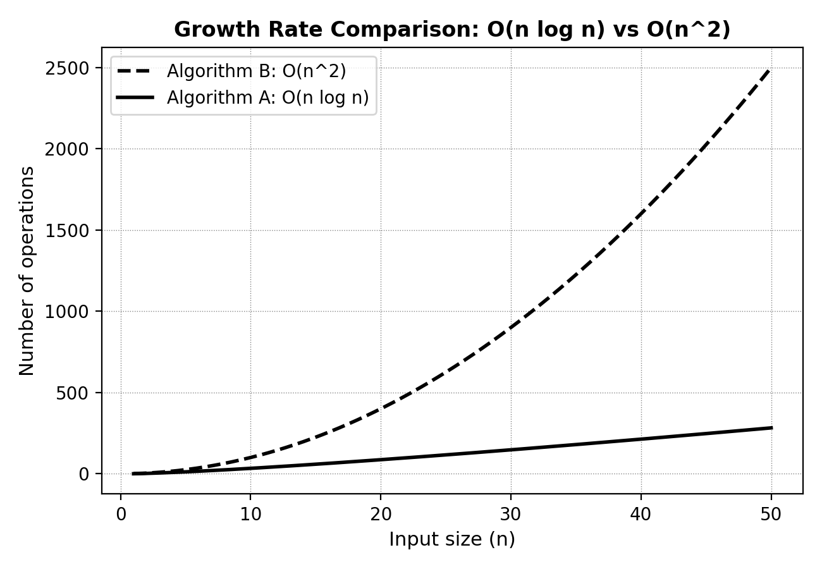
Fig 3: O(n log n) vs O(n^2) growth comparison.
6. Which Algorithm Is Better for Large Datasets, and Why
Algorithm A (O(n log n)) is unambiguously better for large-scale log sorting. As dataset size n increases toward production scale (millions of log entries per day), the gap between n log n and n² widens dramatically — Algorithm B's quadratic cost quickly becomes computationally infeasible (potentially requiring hours instead of seconds), while Algorithm A continues to scale gracefully. Formally, since:
lim (n→∞) [ n log n / n² ] = lim (n→∞) [ log n / n ] = 0
Algorithm A's growth rate is asymptotically dominated by Algorithm B's, confirming n log n = o(n²) (little-o: strictly slower-growing). This mathematically guarantees Algorithm A will outperform Algorithm B for all sufficiently large n.
7. Space Complexity Comparison
- Algorithm A (Merge Sort): O(n) auxiliary space — requires a temporary array to merge sorted halves.
- Algorithm A (Heap Sort variant): O(1) auxiliary space — sorts in-place using a binary heap, no extra array needed.
- Algorithm B (Bubble/Insertion Sort): O(1) auxiliary space — sorts in-place using only a constant number of temporary variables.
8. Identifying the More Memory-Efficient Algorithm
If Algorithm A is implemented as Heap Sort, it matches Algorithm B's O(1) auxiliary space while still retaining the O(n log n) time advantage — making Heap Sort the most memory-efficient AND time-efficient choice overall. If Algorithm A is implemented as Merge Sort, it trades O(n) extra space for guaranteed stability (preserving the relative order of log entries with identical timestamps) and predictable performance, which is often more valuable in a log-sorting context than saving memory, since log servers typically have ample RAM relative to log-batch size.
Overall recommendation: use Heap Sort when memory is constrained and stability is not required; use Merge Sort when stability (e.g., preserving insertion order of same-timestamp logs) is important and O(n) extra memory is acceptable. Either choice is vastly superior to Algorithm B (O(n²)) for production-scale log sorting.
9. Final Conclusion
Comparing the two candidate algorithms using Big-O, Big-Θ, and Big-Ω notation shows that Algorithm A (O(n log n)) asymptotically and practically outperforms Algorithm B (O(n²)) for all sufficiently large input sizes, since n log n = o(n²). While Algorithm B may appear competitive for very small log batches, real-world production log volumes make Algorithm A the only scalable and time-efficient choice. Considering space complexity as well, Heap Sort offers the best overall trade-off — O(n log n) time with only O(1) auxiliary space — making it the recommended algorithm for the software log sorting system.

